Variable Expressions with Exponents Notes
- Example 1
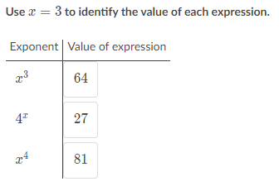

Solutions to Example 1:
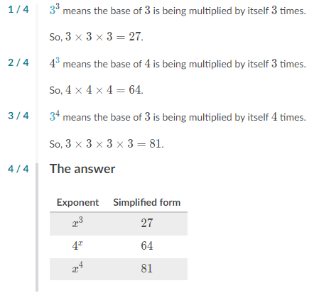
- Example 2
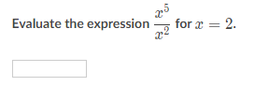
Solutions to Example 2:
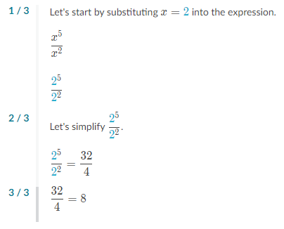

- Example 3
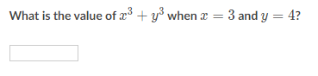
Solutions to Example 3:
